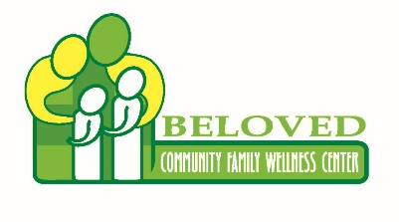
Registration Form

“Wellness Rocks”

Organization Name (please print or type)

Name

Name of attendees

Company address

City, ST Zip Code

Phone 1 | Phone 2

Fax | Email
Donations
Will this Organization donate items for event?
☐Yes ☐No
If yes, please describe items: _________________________________________
__________________________________________________________________________
Tax Deductible-$50.00 Registration Fee
I (we) plan to make this contribution in the form of: ☐cash ☐check.
Please make checks payable to: |  | Beloved Community Family Wellness Center  6821 S. Halsted  Chicago, IL 60621-1833

Completed forms are due by March 8, 2019 to Letitia Williams:
Fax (708)577-5064 or email lwilliams@bcfwc.org
Or Register with Eventbrite @
http://bit.ly/BCFWCWellnessRocks

Acknowledgement Information: Please use the following name(s) in all acknowledgements:

☐I (we) wish to have our gift remain anonymous.
Signature(s) |  | Date

